ASSIGNMENT NO:-1

Name:-RAHIL SHAIKH

ID NO:- vu4S2021003

Div:-A 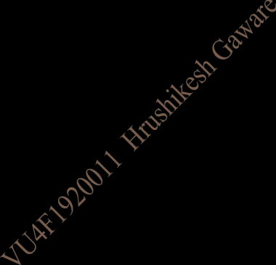

Q.1 :- Write a Python Program to Check Whether a Given Year is a Leap Year

Solution:-

Code:-

n1 = int(input("Enter the year"))

if n1%4==0:

print("Year is Leap")

else :

print("year is not leap")

Output:-

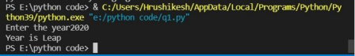1

Q.2:- Write a Python Program to Merge Two Lists and Sort it and Find the Largest Number in a List

Solution:-

Code:- 

first_list = []

second_list = []

count_first_list = int(input("Enter total numbers of the first list : "))

for i in range(1,count_first_list+1):

no = int(input("Enter : "))

first_list.append(no)

count_second_list = int(input("Enter total numbers of the second list : "))

for i in range(1,count_second_list+1):

no = int(input("Enter : "))

second_list.append(no)

2

print("First list : ",first_list)

print("Second list : ",second_list)

final_list = first_list +second_list 

final_list.sort()

print("Final list : ",final_list)

print("Largest number on the list is :",max(final_list))

Output:-

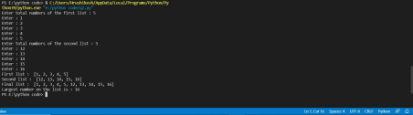

Q.3:- Write a Python Program to Concatenate Two Dictionaries Into One

3

Program:-

def Merge(a1, a2):

return(a2.update(a1))

a1= {'a':45,'b':8}

a2={'d':11,'c':12} 

print(Merge(a1,a2))

print(a2)

Output:-

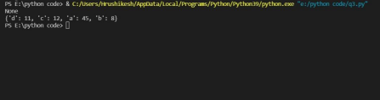

Q.4:- Write a Python Program to Create a Class which Performs Basic Calculator Operations

Program:-

class cal():

def init (self,a,b):

self.a=a

self.b=b

4

def add(self):

return self.a+self.b

def sub(self):

return self.a-self.b

def multi(self):

return self.a*self.b 

def divide(self):

return self.a/self.b

a = int(input("Enter first number"))

b = int(input("Enter the second number:"))

obj=cal(a,b)

while True:

def menu():

x = ('1.Add \n2.sub \n3.multiply \n4.Divide') print(x)

menu()

choice = int(input("Please select one of the following")) if choice == 1:

print("Result: ",obj.add())

elif choice == 2:

print("Result: ",obj.sub())

elif choice == 3:

print("Result: ",obj.multi())

elif choice == 4:

5

print("Result: ",obj.divide())

elif choice == 0:

print("again try one of the following")

break

Output:- 

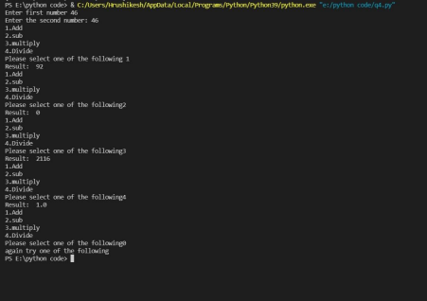Q.5:- Write a Python Program to for multiple inheritance

Program:-

#write program on multiple inheritance

6

class python:

def m(self):

print("python is most easy language")

class html(python):

def m(self):

print("html is the base of the web applications") 

class css(python):

def m(self):

print("css is used for the style")

class django(html,css):

def m(self):

print("html and css used for the frontend and django used for backend")

web = django()

web.m()

html.m(web)

css.m(web)

python.m(web)

Output:-

7